**Microclimatic change explored through artificial shelters in a California dryland system.**

**do we want to say ‘shrub mimic’ right up front in title or save?**

Nargol Ghazian1*, Mario Zuliani1, and Christopher J. Lortie1, 3.

1Department of Biological Science, York University, 4700 Keele St, Toronto, ON M3J 1P3, Canada

3National Centre for Ecological Analysis and Synthesis (NCEAS), 735 State St #300, Santa Barbara, CA 93101, United States

*Corresponding Author: Department of Biological Science, York University, 4700 Keele St, Toronto, ON, M3J 1P3, Canada. Email: [nargolg1@my.yorku.ca](mailto:nargolg1@my.yorku.ca)

**Did Mike fund this at all? Let’s think hard if we need to include?**

**Abstract**

Anthropogenic factors such as climate change, land use, urbanization, alongside the spread of invasive species are some of the challenges impacting the arid and semi-arid regions of the Western United States and globally. Climate change negatively impacts wildfire regimes and in turn increases re-establishment competition between native and invasive vegetation. The canopy of many native plants including shrubs and trees not only provides refuge from predators for some animals but also offers a shelter from climate stressors. The canopy of native vegetation can thus be a refuge critical to the survival of many species, and it is vital to better understand its importance for the conservation and recovery of species in these landscapes. In this study, we tested artificial canopies of two shapes (triangle and rectangle) that were easily assembled and very cost-effective. These shelters were constructed with UV permeable shade cloth and PVC piping. Three light permeabilities including 15%, 50%, and 90% were tested by measuring soil and air temperature with light relative to paired open, non-canopied sites. Shrubs were also instrumented to explore these capacities to mimic their micro-environmental effects locally. Shelters offered more stable temperatures and reductions in light compared to the open and were not significantly different from established shrubs nearby. This suggests that this simple intervention can provide refuge for animals and other plants that potentially approximates established and difficult to establish slow-growing shrub species within this California Desert ecosystem.

NEEDS one more edit but much better!! Need to have KEY findings pop, do not need to report all results, ie I cut some minor ones, and I think we are good to here, just edit again for flow. depending on journal rules, ‘could’ add one more sentence even more clearly stating **hypothesis - ie that canopy effects of shrubs can be simulated using artificial canopies in deserts.**

**Keywords:** climate change, micro-climate, animals, temperature, light, shelter, conservation, restoration.

**Introduction**

**Topic sentence first to set picture without citations - Climate change in arid and semi-arid regions is a critical issue globally.** The rate of anthropogenic climate change is rapidly increasing in deserts and semi-arid grasslands (Citations). These changes in turn precipitate extensive ecological shifts including…. species loss (citations), range shifts (citations), change in interactions (citations), increased invasion by exotic plants (citations), and additional stress on resident species in these harsh environments (cites). (Abatzoglou and Kolden 2011). Factors such as land-use changes including agriculture in drylands (Germano et al. 2011; Eliason and Allen 1997) can further decrease biodiversity by reducing the available terrestrial habitat for plants and animals (Nopper et al. 2018; Irwin et al. 2010; Elmqvist 2013). In deserts, animals will not only experience large scale changes such as drought, but also small scale changes such as relatively more extreme fluctuations abiotic factors such as temperature (Pugnaire and Luque 2001). This evidence suggests that not only do gross, large-scale changes in climate exert pressure on communities and sensitive species in drylands, but fine-scale changes can fluctuations can potentially further exacerbate loss. Consequently, the importance of refuges, shelters, or other attributes in the landscape the plants and animals use to mediate climate effects are likely increasingly important.

Vegetation is key aspect of most landscapes in drylands. It covers a terrestrial habitat is an important characteristic that can influence: foraging site selection (Thiele, Jeltsch, and Blaum 2008), reproduction (Thyen and Exo 2005), predator-prey interaction (Barbosa and Castellanos 2005), and thermoregulation (Parmenter and MacMahon 1983) CLUNKY revise - clearly state three ways that vegetation is important - mechanistically - cover, soil retention, water dynamics? refuges for plants and animals. and then end with typically in drylands, shrubs are the dominant vegetation (citations), and thus shrubs are a useful set of target species to use in examining climate change impacts and strategies used by associated plants and animals to adapt to climate (citations). etc - set up flow….

The state of California is home to many diverse landscapes, many which are dominated by a relatively high diversity of shrubs (Stuart and Sawyer 2001). Species such as *Ephedra Californica* (Mormon Tea) are known to be foundational plants, able to facilitate other taxa through various mechanistic pathways that include, but are not limited to, seed trapping, abiotic stress amelioration, herbivore protection, magnet pollination, facilitation-mediated secondary seed dispersal, and soil modification (Filazzola and Lortie 2014; Lortie, Filazzola, and Sotomayor 2016). An important agent of structural facilitation is shrub canopy (Filazzola et al. 2017). Canopy microclimates are generally cooler, more humid, and experience lower solar radiation compared to the open sites (Filazzola et al. 2017; Holzapfel and Mahall 1999). Shrubs fulfill a critical role; hence, more species are associated with shrubs than open spaces (Lortie, Filazzola, and Sotomayor 2016). Shrubs can be both expanding in cover in some grassland systems, yet declining in others. Given their incredible role as foundation species, it is both reasonable A) to test their role for simple functions such as thermal shelter for animals and B) directly test shelters through mimics as means to conserve heterogeneity - yes I would argue this too - use all these ideas just set up logic in paragraph more clearly in deserts for animals since conserving structural diversity in all ecosystems, in addition to species diversity is critical (Brooks 1999; Cowling et al. 1999; Morris 2000). Although shrubs can perform the above function, it would be ideal to have the capacity to mimic this to augment and enhance low shrub cover areas and serve as stopgap tools for conservation great - I might move this to next paragraph.… Moreover, it’s important to direct and sample value of more shelter in some dryland systems as a form of thermal refuges and alternate modes of conservation whilst landscape recovery is made and new shrubs are grown.

Topic sentence first - perhaps something about shrubs are ideal vegetation to consider for restoration and management in drylands. Nonetheless, shrubs in these systems are typicall slow growing? (citations), difficult to establish (citations), and frequently cleared by ranchers, agriculture, and historically in solar farms as well (Citations etc). Hence, artificial canopies can provide an important surrogate test for canopy effects in drylands. There is a relatively long history of use in ecology. then fo into this —- artificial canopies has been used to explore drought using rainout shelters and were highly effective. (citations). Open-Top-Chambers (OTC), have been used to….. (citations). Finally, in deserts??? both have been used but??? what is novel here - what is the gap we are filling - not at small scales roughly the size of resident etc same as other para above - logically and clearly set up your story is reader lead to see the why super clearly in this study…

have been used to study the change in a variety of abiotic parameters such as CO2, temperature, soil temperature, solar radiation, and humidity (Yahdjian and Sala 2002; Marion et al. 1997). Although these shelters are effective, they’re relatively expensive to build and may be difficult to assemble in a short period of time. Rainout shelters used in semi-desert grassland studies have proven to be effective in altering precipitation, yet they have minimal impact on changing other variables such as air and soil temperature, humidity, and light (English et al. 2005). On the other hand, OTCs have been experimentally used to increase temperature in plant studies in high-latitude ecosystems (Marion et al. 1997). see above - re-organize - is that it for shelter research in deserts ecologically? check the journal we want to submit to first and the second choice too. Although these shelters are effective at manipulating different abiotic parameters, they’re relatively expensive to build and may be difficult to assemble in a short period - meh - OK so I guess ok to list gaps - typically large (not shrub sized), expensive to deploy, and have not measured fine-scale microclimate data underneath? or have they?. It is therefore key to take advantage of the variability in temperature and light in drylands to explore the effects of artificialy shelters that are inexpensive and easily-built and MOST importantly see above - shrubs are hard to setup.. .etc I think logic is shrubs great but hard to manage, shelters used in ecology but mostly at larger sizes and not as a surrogate for vegetation, and it would be worthwhile to know mechanistically how small shelters compare to shrub microclimate effects in the exact same systems…. THEN you are set up to go for the paper. readers will be like.. .AHHH got it.

so flow

para 1 climate change rates increasing in deserts - species need to adapt through many strategies. HECK use something like that as topic sentence

Para 2 Vegetation is a critical component of dryland ecosystems. then explain why.

Para 3 Shrubs are the dominant vegetation cover class in many drylands and thus be great to be able to better understand and manage them… however… old, hard to recruit etc.. and in ecology- we use shelters… set up how then explain gaps - size, scale, cost, and purpose novel here PLUS coupled with nearby shrubs in the same system is key.

The concept of shade from higher and more variable temperatures in drylands is an important idea to explore experimentally for conservation and restoration. Using a California desert ecosystem, we tested an inexpensive shelter alternative to shrubs for shape and permeability in concert with paired microclimatic measures under shrubs and under these structures. The following three goals - never love goals - either objectives or hypothesis? H: Artificial shelters can mimic the microclimatic shelter effects of shrub canopy on temp and RH. The following predictions tested included: 1) shaped of shelter is important, 2) UV permeability can shift light and temp regimes experienced, and 3) a combination of these two key factors in contructing shelters can effectively mimic some of the effects of shrub canopies at these fine-scales. I prefer this spin personally. Less descriptive and more predictive. and True!@

Do you need a prediction for the logger versus weather station data? Kind of a cool test of refuge hypothesis - or do you want to call it shelter hypothesis throughout because the effect is shelter or canopy and refuge implies we are measuring what the other plants and animals are doing? not sure. either way- Canopy hypothesis and if cooler then weather station, nice support in addition to the difference from open that shelters and shrubs CAN provide refuge thermally.

ALSO - the whole paper is kind of about thermal right - and permeability is about light because light can make it much warmer and you test that - so you are kind of showing it is a DIRECT shade effect of the canopy and not some other reason right??? either way, make logic of light clearer because you do test different light permeabilities..

describing the methodology of constructing UPSS. 2) Exploring UPSS effects on canopy microclimate, including temperature and light intensity, relative to the open and shrub. 3) Understanding how different light permeabilities and shelter shapes influence the above parameters. Artificial structures are not uncommon in drylands for energy and development (Pasqualetti 2001; Lovich and Ennen 2011) move up to relevant paragraph or better yet save for Discussion; thus, a deeper understanding of physical structures impacts at fine-scales can also inform some of the ecology of these changes.

**Materials & Methods**

***Study Site***

This study was conducted in Panoche Hills Management Area located on the western edge of the San Joaquin Valley, California (Bureau of Land Management; 36°41.78′ N, 120°47.89′ W). The regional climate can be characterized as arid/semi-arid. The average annual precipitation is 25.5 cm with an annual low and high temperature of 10.4 °C (50.72 °F) and 24.6 °C (76.3 °F), respectively. Winter and fall are considered to be the wettest seasons. The mean temperature observed in May is 20.4 °C (68.72 °F) and 23.7 °C (74.66 °F) in June (Los Baños Weather Station, <http://www.usclimatedata.com/>). The dominant shrub species is.. Ephedra californica etc… talk about the shrubs and vegetation in general - no need to highlight invasives..others propose it is an Ephedra parkland - that is a cool angle.

region is heavily dominated by invasive grasses such including *Bromus madritensis ssp. Rubens, Bromus hordeaceus, Erodium cicutarium* and *Schismus barbatus* (Filazzola et al. 2017)*.* The study took place between May 20th to June 12th, 2019. the whole study? I thought you left out for a longer time?

***Shelter Construction***

Shelters were constructed using PVC piping and UV permeable shade cloths at three permeabilities including 15%, 50%, and 90%. The open at 0% light blockage served as the procedural control because the frame was still deployed. The cloths were attached to the PVC using zip ties (Figure 1). Table A (Supplementary Appendix) describes the number of pieces at specific dimensions and diameter needed to build each triangle or square shelter. There were six replicates of each shape. Two for each blockage percentage for a total of 12 replicates. Pipes were slid onto metal stakes and secured into ground for stability (Supplementary Appendix; B). Latitude and longitude of each shelter-open pair was also recorded (H; Supplementary Appendix). maybe set up as triplicate - ie shelter, shrub, and open and describe like that instead? so explain how you set up the three treatments - shelter, shrub, and open - then have a paragraph for shelter, then for shrub, and then for open (maybe do not need much for that - just within 1m etc.., no shrubs are major vegetation etc?

Rectangular (referred to as square in stats) shelters consisted of two sides with two 61 cm ½ inch pipes facing the ground connected to a 61 cm ¾ inch pipe using a 90° elbow. Triangular shelters were built using a 75 cm ¾ inch top pipe connected to a ½ inch to ¾ inch adapter. The adapter was then attached to a ½ inch 3-way 90° elbow fitted with two 61 cm ½ pipes. Cloths were used to cover two side of the triangular shelters and three sides of the rectangular shelters. The cardinal direction or orientation of each shelter was decided using a random number table and recorded. Shelters were inspected weekly throughout deployment.

***Shelter Micro-climatic Measurements***

To measure the difference in light and temperature within shelters and between shelters and open microsites and shrubs?, Onset HOBO Temperature/Light Pendant (8K) loggers were placed inside and directly outside to the right of the shelters. A total of 24 pendants were used, where each pendant was tied to a plastic stake using a zip tie, recording data at 1 hour intervals. Stakes were hammered into the ground until stable with ~10 cm remaining above ground. This was done to ensure that logger data were not influenced by ground cover and true ambient conditions both inside and in the open were recorded. Air temperature (°F) and light intensity (lum/ft2) were recorded hourly - were they? or were they recorded at higher frequencies then summarized to hourly?. Loggers were placed out mid-May and collected in mid-June to account for spring-summer seasonal variation - good.

***Shrub Micro-climatic Measurements***

A set of Onset HOBO Temperature/Light Pendant (8K) (one soil and one ambient) were placed below the base of Ephedra californica shrub canopies microsite to log temperature and light intensity data in 1 hour intervals. The ambient pendants were secured to pegs using the same protocol as above. Latitude and longitude coordinates of each shrub were recorded upon deployment of loggers. There were 7 shrub microsites resulting in a total of 14 loggers being used (I; Supplementary Appendix). did you measure shrub sizes? did you measure other vegetation cover - under shrub, open or under shelters? was the ground bare?

**Site-level climate *measurements***

Weather data were download for the study site for the duration of the study (Los Baños Weather Station at 37°03.30′N, 120°51.00′W, http://www.usclimatedata.com/). Date, air temperature, and soil temperature (°F) with solar radiation (W/m2) were exported from this site and published (Citation to Figshare dataset for the site-level data).

***Statistical Analyses***

All statistics were performed using R version 4.0.0 (R Core Team 2020). Code is published on Zenodo (citation) and micro-climate data are published on Figshare (citation). Q-Q plots were used to examine the distribution of data and to check for normality and homoscedasticity (Schützenmeister, Jensen, and Piepho 2012). The relationship between temperature and light intensity was examined using Kendall’s rank correlation (non-parametric, continuous data). Generalized Linear Models (GLM) were used to compare temperature, light intensity, cover type, and microsite (Nelder and Wedderburn 1972). GLM dispersion parameters alongside AIC scores were used to compare and select the appropriate family to fit to models (Richards, Whittingham, and Stephens 2011). What R packages did you use to do GLMS etc? Gaussian family distribution - check journal for how they say this - typically say Data were modeled as.. etc was fitted to temperature models while the quasi-Poisson family was fitted to light intensity. Post-hoc tests were done using the function *emmeans* from the *emmeans* R package (Lenth and Herve 2019).

**Results**

Temperature significantly increased with light intensity (Kendall’s tau= 0.281, p=0.0001; G in Supplementary Appendix). This was true regardless of the microsite - stats? I think I would fit a GLM instead… with light as y, then x being microsite (shrub, open, shelter). All microsites significantly predicted temperature??? except for shrub (GLM, p<0.05) (Table 1) what do you mean predict?. Square were hotter? brighter than triangle (Figure X, post-hoc test, p=0.0034), while triangle was significantly cooler/hotter than open microsites? (Figure X, post-hoc test, p= 0.0001) (Table 3). be specific - check a few papers that are similar c (Figure 2). Additionally, triangle showed the lowest estimated marginalized mean (EMM) in temperature (70.5 ± 0.0467 °F), whilst the shrub showed the highest EMM relative to all other microsites (73.9± 0.351 °F) (Table 2) - why not have a cool simple table that shows relationships? list all microsites, then in table list hottest coldest? Did the time of dat matter?. There were also significant differences between all microsites when predicting?? light intensity - Just say highest light intensities were.. etc. (GLM, p<0.05) (Table 4). The triangular shelter, square shelter alongside shrub showed the lowest maximum of light intensity experienced under a canopy - good be specifci (Figure 3). just state which ones were different - triangle most light, then square, then shrub, then one? did the differences interact with permeability of cloth? if NOT - that is pretty amazing.. , except between shrub and square shelter, and shrub and triangular shelter, and square and triangle??? confusing - just state differences etc. (Table 6). Square experienced the lowest EMM in light intensity (7.424± 0.04371 lum/ft2), followed by triangle (7.529± 0.05124 lum/ft2) whereas the open experienced the highest EMM - better (8.111± 0.018 lum/ft2) (Table 4). Further analyses showed that the triangular and square shelters are significantly different at 15%, 50%, and 90% when predicting light intensity, but are only significantly different at 90% when predicting temperature (E and F; Supplementary Appendix) Confusing - revise all this, have a simple logical table showing differences, state whether shape interacted with light levels, use specific language, state relationships .

need to reorganize above

1. state patterns of difference in light and temp whether they interacted with permeability
2. state whether light predicts temps as you would expect - the same for all shapes and for all permeabilities? this is tricky.
3. state which shelter provided the best refuge - coolest but still had light?
4. state which combination best approximated the shrubs…
5. calculate Rii for shrub-open, then for shelter-open treatment combinations and plot that out too - lets’ see the effect sizes to see data that way - might simplify
6. explain how you are handling time during day - not clear above - did you only test means or max and min values too? How did you aggregate hours - or did you next hour inside treatment to address repeated measures - or did you just use daily means for light and temp and then nest inside daily. I know what you did, haha, but it is not clear in methods or results when you read it

Additionally, the variation in mean temperature between weather station data and data obtained via loggers was tested and showed to be significantly different for almost all microsites (GLM, p<0.05) (Table1). Post-hoc analyses demonstrated that in particular there was a significant difference between weather station and square (post-hoc p= 0.0001) HOW? warmer or cooler??? so is the local weather station estimating higher or lower temps? THIS IS really important right - ie the whole point is to test refuge hypothesis that shelters and shrubs can provide - so I hope cooler than a weather station….. , weather station and shrub (post-hoc p= 0.0001), and weather station and the open?? (post-hoc p= 0.0001) (FIgure 3, Table 3). I would add a figure for this and for loggers versus station I might just use daily means for temp.

So, I LOVE what you are sitting on here but I am a bit lost. I think it is just organization but the figures need to pop, you need a figure for micro versus macro data, and then we can chat. Also, calculate a shelter-open RII for temp, Rii light and do same for shrub-open etc then we can check that.

Check Sotomayor paper I am attaching. ALSO send me any papers that like theirs and ours - I want to see how others do this too. Yours is unique of course, but there are some similarities.

also, see fig 3, second plot, of Zhang and Tielborger - stress on x, dots with connected lines, different lines for different colors etc- ALSO looks like they used RII TOO!! OK sweet. nice precendent. and in a TOP journal so that is good too. again - not saying you have to change all this at all- just check other stuff for us and give us a list of options. and check the main two journals you want and see what similar papers do there. Mostly the edits are about writing.

**Discussion**

Shrubs and structural heterogeneity are important components of ecosystems relevant to the conservation and restoration of other plants and animals YES. A shelter, vegetation, or artificial cover of any sort in deserts can provide amelioration or even just differences in the temperature and light at fine-scales that provides plants and particularly animals with thermal options (Ivey et al. 2020; Attum and Eason 2006). In plants, this can take the form of different germination conditions (Szwagrzyk, Szewczyk, and Bodziarczyk 2001; Went 1949). In animals, this can include cooling (citations), foraging for prey under canopies (etc), or habitat for burrow and dens (citations). Here we tested the hypothesis!!! YAH so put that hypothesis in the Intro too.. The hypothesis that artificial shelter can provide a similar thermal and light habitat to shrub canopies was supported in this study. The X shape with Y permeability best approximated the canopy effects nearby Ephedra californica. The presence of shelter effectively reduced mean temperature and light intensity, and all? shelters were similar to shrub canopies and different from coarser-scale climate estimate from a nearby weather station. This evidence suggest that shelters can provide and important mechanism or tool for stakeholders to provide habitat for plants and animals either as a temporary stepping stone in restoration strategies or as a means to enhance habitat quality through simple and cost effective interventions. GOOD - just ensure you mention each prediction - Do you need a prediction for the logger versus weather station data?

TOPIC sentence first - is this paragraph a thermal mechanism discussion? As previously stated, the greatest mean in temperature was experienced by the open microsite and the lowest was experienced by the triangular shelter. The greatest frequency of hotter temperatures was also observed in the open (J; Supplementary Appendix), as opposed to the other canopied microsites. Additionally, both shrubs and artificial shelters reduced the amount of extreme light experienced under the canopy. Although both square and triangle reduced the mean temperature and light intensity experienced relative to the open, if we were to select one shape and one blockage intensity as the most effective at reducing both parameters it would be triangle at 90% blockage revise - and tie into the literature - need to use physics, plant physiology, canopy shape to explain differences between shapes - KEY -these is lots of lit on this… These fine-scale variations in micro-climatic conditions at the various microsites may be important in maintaining biodiverse ecosystems since different animals and plants may require different climatic conditions for growth, survival, and reproduction. revise paragraph - no citations, no ties into literature - what is the point? IS rthis a shape paragraph?

Discussion outline to consider

Paragraph 1. Big picture, H supported, preds a,b,c explained, implications

Paragraph 2 - your call - explain why shape differs? Good but not critical?

Paragraph 3 - explain which combination best approximated shrubs and why KEY

Paragraph 4 - explain why you think loggers different from weather station KEY

Paragraph 5 - optional, discuss value of micro-environmental heterogeneity for species - ie provides different niches, so different shelter, shrubs, and open all important?

Shaded microhabitats are a vital components that increase the thermal and structural heterogeneity for a variety of animals such as ectotherms, in addition to providing refuge (Bauwens, Hertz, and Castilla 1996; Diaz and Cabezas-Diaz 2004). Our data support that shelters too can act similar to vegetation and thus increase the thermal heterogeneity within a given environment see ave..… In California, climate change is interfering with wildfire regimes and altering biological communities (Bishop et al. 2019). Not only can post-disturbance recovery of vegetation be slow(Berry et al. 2016), but competition and invasion by non-natives are amongst other challenges slowing the recruitment of native vegetation (Bowman et al. 2009, 2011). Hence, the benefit of artificial shelters as a mode of conservation is evident whilst other efforts are made to re-establish the native community and the natural vegetation has had the time and resources to re-emerge.

Discussion needs A LOT More work. Much more development.

**Conclusion**

Signs of human-induced climate change is already visible in a variety of ecosystems. Species all around the world face changes in distribution and abundance due to migration and range shift (Midgley et al. 2002). This change with impact the physiology, growth, and productivity of biota(Cannell 1998), as well as their behaviour( Walther, Burga, and Edwards 2001). Given the current rates, it will not be long before species can no longer physiologically and behaviourally mitigate the impacts of climate change. Animals such as lizards may already be over-expending energy when trying to thermoregulation(Vickers, Manicom, and Schwarzkopf 2011). This study suggests that shelters offer a mechanism to create climate refuges as a temporary solution or a long-term strategy, and as an effective form of interference for today’s every growing anthropogenic disturbances. Great implications here. nice end.

**Funding**

This research was made possible through a Natural Sciences and Engineering Research Council of Canada (NSERC) grant awarded to C.J.L. and the Mitacs Globalink award, alongside York University Faculty of Graduate Studies (FGS) fund granted to N.G. and M.Z.

**Acknowledgements**

We are thankful to BLM for allowing us to conduct research in their land. We are grateful to M. MacDonald for her help in designing the project and editing the manuscript. We also thank J. Braun, M. Owen, and S. Haas for their feedback on statistical analyses.

**Work Cited**

Abatzoglou, John T., and Crystal A. Kolden. 2011. “Climate Change in Western US Deserts: Potential for Increased Wildfire and Invasive Annual Grasses.” *Rangeland Ecology & Management* 64 (5): 471–78. https://doi.org/10.2111/REM-D-09-00151.1.

Attum, Omar A., and Perri K. Eason. 2006. “Effects of Vegetation Loss on a Sand Dune Lizard.” Edited by Ribic. *Journal of Wildlife Management* 70 (1): 27–30. https://doi.org/10.2193/0022-541X(2006)70[27:EOVLOA]2.0.CO;2.

Barbosa, Pedro, and Ignacio Castellanos, eds. 2005. *Ecology of Predator-Prey Interactions*. Oxford ; New York: Oxford University Press.

Bauwens, Dirk, Paul E. Hertz, and Aurora M. Castilla. 1996. “Thermoregulation in a Lacertid Lizard: The Relative Contributions of Distinct Behavioral Mechanisms.” *Ecology* 77 (6): 1818–30. https://doi.org/10.2307/2265786.

Berry, Kristin H., James F. Weigand, Timothy A. Gowan, and Jeremy S. Mack. 2016. “Bidirectional Recovery Patterns of Mojave Desert Vegetation in an Aqueduct Pipeline Corridor after 36 Years: I. Perennial Shrubs and Grasses.” *Journal of Arid Environments* 124 (January): 413–25. https://doi.org/10.1016/j.jaridenv.2015.03.004.

Bishop, Tara B. B., Richard A. Gill, Brock R. McMillan, and Samuel B. St. Clair. 2019. “Fire, Rodent Herbivory, and Plant Competition: Implications for Invasion and Altered Fire Regimes in the Mojave Desert.” *Oecologia*, November. https://doi.org/10.1007/s00442-019-04562-2.

Bowman, D. M. J. S., J. K. Balch, P. Artaxo, W. J. Bond, J. M. Carlson, M. A. Cochrane, C. M. D’Antonio, et al. 2009. “Fire in the Earth System.” *Science* 324 (5926): 481–84. https://doi.org/10.1126/science.1163886.

Bowman, David M. J. S., Jennifer Balch, Paulo Artaxo, William J. Bond, Mark A. Cochrane, Carla M. D’Antonio, Ruth DeFries, et al. 2011. “The Human Dimension of Fire Regimes on Earth: The Human Dimension of Fire Regimes on Earth.” *Journal of Biogeography* 38 (12): 2223–36. https://doi.org/10.1111/j.1365-2699.2011.02595.x.

Brooks, Matthew. 1999. “Effects of Protective Fencing on Birds, Lizards, and Black-Tailed Hares in the Western Mojave Desert.” *Environmental Management* 23 (3): 387–400. https://doi.org/10.1007/s002679900194.

Cannell, M. 1998. “UK Conifer Forests May Be Growing Faster in Response to Increased N Deposition, Atmospheric CO2 and Temperature.” *Forestry* 71 (4): 277–96. https://doi.org/10.1093/forestry/71.4.277.

Cowling, R. M., R. L. Pressey, A. T. Lombard, P. G. Desmet, and A. G. Ellis. 1999. “From Representation to Persistence: Requirements for a Sustainable System of Conservation Areas in the Species-Rich Mediterranean-Climate Desert of Southern Africa.” *Diversity <html_ent Glyph="@amp;" Ascii="&amp;"/> Distributions* 5 (1–2): 51–71. https://doi.org/10.1046/j.1472-4642.1999.00038.x.

Diaz, J. A., and S. Cabezas-Diaz. 2004. “Seasonal Variation in the Contribution of Different Behavioural Mechanisms to Lizard Thermoregulation.” *Functional Ecology* 18 (6): 867–75. https://doi.org/10.1111/j.0269-8463.2004.00916.x.

Eliason, Scott A., and Edith B. Allen. 1997. “Exotic Grass Competition in Suppressing Native Shrubland Re-Establishment.” *Restoration Ecology* 5 (3): 245–55. https://doi.org/10.1046/j.1526-100X.1997.09729.x.

Elmqvist, Thomas, ed. 2013. *Urbanization, Biodiversity and Ecosystem Services: Challenges and Opportunities: A Global Assessment ; a Part of the Cities and Biodiversity Outlook Project*. Springer Open. Dordrecht: Springer.

English, N.B., J.F. Weltzin, A. Fravolini, L. Thomas, and D.G. Williams. 2005. “The Influence of Soil Texture and Vegetation on Soil Moisture under Rainout Shelters in a Semi-Desert Grassland.” *Journal of Arid Environments* 63 (1): 324–43. https://doi.org/10.1016/j.jaridenv.2005.03.013.

Filazzola, Alessandro, and Christopher J. Lortie. 2014. “A Systematic Review and Conceptual Framework for the Mechanistic Pathways of Nurse Plants: A Systematic Review of Nurse-Plant Mechanisms.” *Global Ecology and Biogeography* 23 (12): 1335–45. https://doi.org/10.1111/geb.12202.

Filazzola, Alessandro, Michael Westphal, Michael Powers, Amanda Rae Liczner, Deborah A. (Smith) Woollett, Brent Johnson, and Christopher J. Lortie. 2017. “Non-Trophic Interactions in Deserts: Facilitation, Interference, and an Endangered Lizard Species.” *Basic and Applied Ecology* 20 (May): 51–61. https://doi.org/10.1016/j.baae.2017.01.002.

Germano, David J., Galen B. Rathbun, Lawrence R. Saslaw, Brian L. Cypher, Ellen A. Cypher, and Larry M. Vredenburgh. 2011. “The San Joaquin Desert of California: Ecologically Misunderstood and Overlooked.” *Natural Areas Journal* 31 (2): 138–47. https://doi.org/10.3375/043.031.0206.

Holzapfel, Claus, and Bruce E. Mahall. 1999. “BIDIRECTIONAL FACILITATION AND INTERFERENCE BETWEEN SHRUBS AND ANNUALS IN THE MOJAVE DESERT.” *Ecology* 80 (5): 1747–61. https://doi.org/10.1890/0012-9658(1999)080[1747:BFAIBS]2.0.CO;2.

Irwin, Mitchell T., Patricia C. Wright, Christopher Birkinshaw, Brian L. Fisher, Charlie J. Gardner, Julian Glos, Steven M. Goodman, et al. 2010. “Patterns of Species Change in Anthropogenically Disturbed Forests of Madagascar.” *Biological Conservation* 143 (10): 2351–62. https://doi.org/10.1016/j.biocon.2010.01.023.

Ivey, Kathleen N, Margaret Cornwall, Hayley Crowell, Nargol Ghazian, Emmeleia Nix, Malory Owen, Mario Zuliani, Christopher J Lortie, Michael Westphal, and Emily Taylor. 2020. “Thermal Ecology of the Federally Endangered Blunt-Nosed Leopard Lizard (Gambelia Sila).” Edited by Steven Cooke. *Conservation Physiology* 8 (1): coaa014. https://doi.org/10.1093/conphys/coaa014.

Lenth, R, and M Herve. 2019. *Emmeans, Estimated Marginal Means, Aka Least-Squared Means.* (version 1.1.2).

Lortie, Christopher J., Alessandro Filazzola, and Diego A. Sotomayor. 2016. “Functional Assessment of Animal Interactions with Shrub-Facilitation Complexes: A Formal Synthesis and Conceptual Framework.” Edited by Richard Michalet. *Functional Ecology* 30 (1): 41–51. https://doi.org/10.1111/1365-2435.12530.

Lovich, Jeffrey E., and Joshua R. Ennen. 2011. “Wildlife Conservation and Solar Energy Development in the Desert Southwest, United States.” *BioScience* 61 (12): 982–92. https://doi.org/10.1525/bio.2011.61.12.8.

Marion, G.M., G.H.R. Henry, D.W. Freckman, J. Johnstone, G. Jones, M.H. Jones, E. Lévesque, et al. 1997. “Open-Top Designs for Manipulating Field Temperature in High-Latitude Ecosystems.” *Global Change Biology* 3 (S1): 20–32. https://doi.org/10.1111/j.1365-2486.1997.gcb136.x.

Midgley, G.F., L. Hannah, D. Millar, M.C. Rutherford, and L.W. Powrie. 2002. “Assessing the Vulnerability of Species Richness to Anthropogenic Climate Change in a Biodiversity Hotspot.” *Global Ecology and Biogeography* 11 (6): 445–51. https://doi.org/10.1046/j.1466-822X.2002.00307.x.

Morris, M.G. 2000. “The Effects of Structure and Its Dynamics on the Ecology and Conservation of Arthropods in British Grasslands.” *Biological Conservation* 95 (2): 129–42. https://doi.org/10.1016/S0006-3207(00)00028-8.

Nopper, Joachim, Jana C. Riemann, Katja Brinkmann, Mark-Oliver Rödel, and Jörg U. Ganzhorn. 2018. “Differences in Land Cover – Biodiversity Relationships Complicate the Assignment of Conservation Values in Human-Used Landscapes.” *Ecological Indicators* 90 (July): 112–19. https://doi.org/10.1016/j.ecolind.2018.02.004.

Parmenter, Robert R., and James A. MacMahon. 1983. “Factors Determining the Abundance and Distribution of Rodents in a Shrub-Steppe Ecosystem: The Role of Shrubs.” *Oecologia* 59 (2–3): 145–56. https://doi.org/10.1007/BF00378831.

Pasqualetti, Martin J. 2001. “Wind Energy Landscapes: Society and Technology in the California Desert.” *Society & Natural Resources* 14 (8): 689–99. https://doi.org/10.1080/08941920117490.

R Core Team. 2020. *R* (version 3.6.1).

Richards, Shane A., Mark J. Whittingham, and Philip A. Stephens. 2011. “Model Selection and Model Averaging in Behavioural Ecology: The Utility of the IT-AIC Framework.” *Behavioral Ecology and Sociobiology* 65 (1): 77–89. https://doi.org/10.1007/s00265-010-1035-8.

Schützenmeister, A., U. Jensen, and H.-P. Piepho. 2012. “Checking Normality and Homoscedasticity in the General Linear Model Using Diagnostic Plots.” *Communications in Statistics - Simulation and Computation* 41 (2): 141–54. https://doi.org/10.1080/03610918.2011.582560.

Stuart, John David, and John O. Sawyer. 2001. *Trees and Shrubs of California*. California Natural History Guides 62. Berkeley: University of California Press.

Szwagrzyk, Jerzy, Janusz Szewczyk, and Jan Bodziarczyk. 2001. “Dynamics of Seedling Banks in Beech Forest: Results of a 10-Year Study on Germination, Growth and Survival.” *Forest Ecology and Management* 141 (3): 237–50. https://doi.org/10.1016/S0378-1127(00)00332-7.

Thiele, T., F. Jeltsch, and N. Blaum. 2008. “Importance of Woody Vegetation for Foraging Site Selection in the Southern Pied Babbler (Turdoides Bicolor) under Two Different Land Use Regimes.” *Journal of Arid Environments* 72 (4): 471–82. https://doi.org/10.1016/j.jaridenv.2007.06.011.

Thyen, S., and K.-M. Exo. 2005. “Interactive Effects of Time and Vegetation on Reproduction of Redshanks (Tringa Totanus) Breeding in Wadden Sea Salt Marshes.” *Journal of Ornithology* 146 (3): 215–25. https://doi.org/10.1007/s10336-005-0082-9.

Urban, M. C. 2015. “Accelerating Extinction Risk from Climate Change.” *Science* 348 (6234): 571–73. https://doi.org/10.1126/science.aaa4984.

Vickers, Mathew, Carryn Manicom, and Lin Schwarzkopf. 2011. “Extending the Cost-Benefit Model of Thermoregulation: High-Temperature Environments.” *The American Naturalist* 177 (4): 452–61. https://doi.org/10.1086/658150.

Walther, G.-R., Conradin A. Burga, and Peter J. Edwards, eds. 2001. *“Fingerprints” of Climate Change: Adapted Behaviour and Shifting Species Ranges*. New York: Kluwer Academic/Plenum Publishers.

Went, F. W. 1949. “Ecology of Desert Plants. II. The Effect of Rain and Temperature on Germination and Growth.” *Ecology* 30 (1): 1–13. https://doi.org/10.2307/1932273.

Yahdjian, Laura, and Osvaldo E. Sala. 2002. “A Rainout Shelter Design for Intercepting Different Amounts of Rainfall.” *Oecologia* 133 (2): 95–101. https://doi.org/10.1007/s00442-002-1024-3.

***Tables first,***

***then figure legends,***

***then figures for most journals.***

**Figures & Tables**

**why not have the same format figure for 1 and 2 - ie temp and light - same style plot _ I like the idea of showing mean and max too.**

**Figure 1. MOVE pictures to appendix? Left-Triangular shelter with 90% shade cloth attached to PVC skeleton using zip ties. Right-Rectangular shelter with 15% shade cloth attached to two PVC skeletal frames. More detail please.**

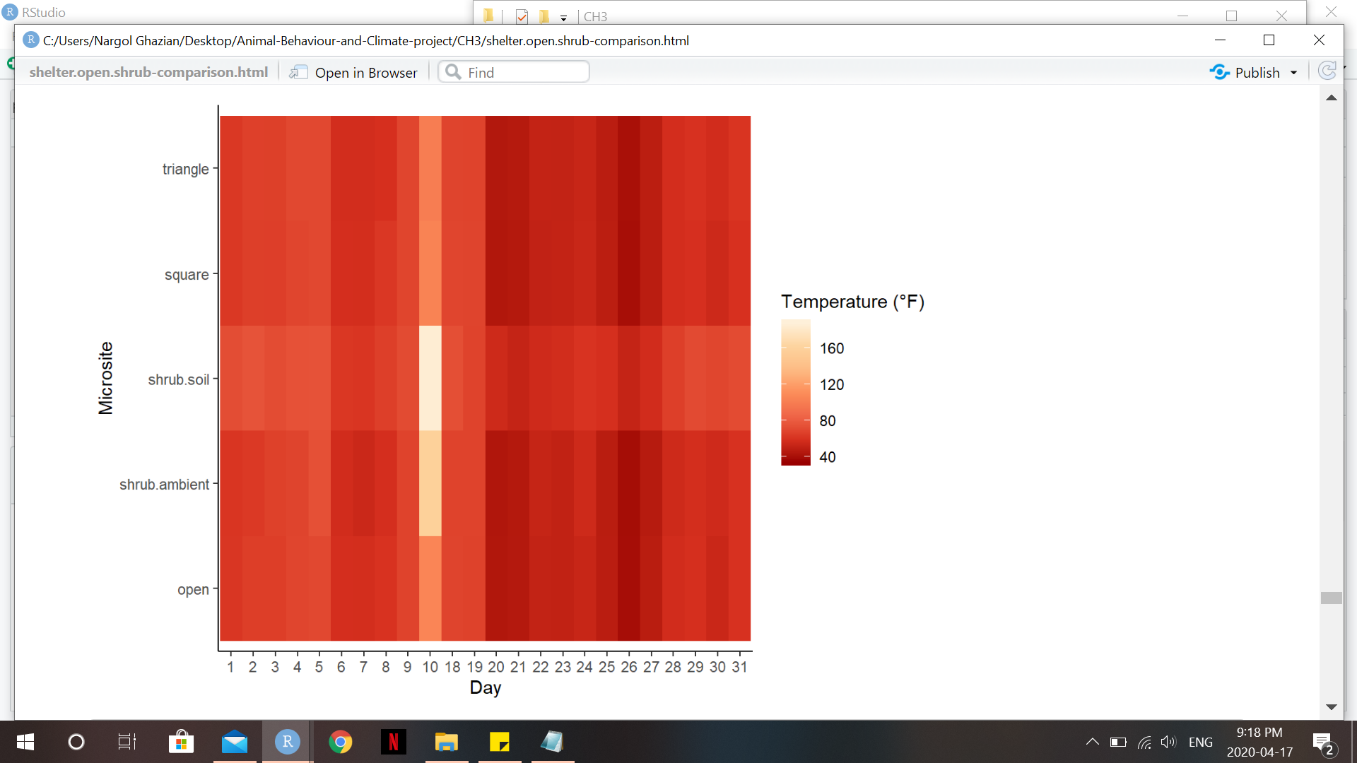

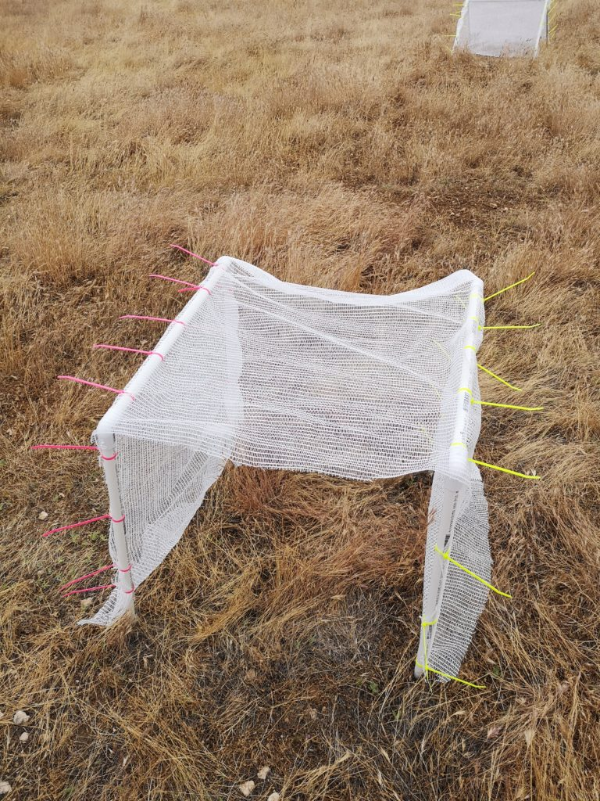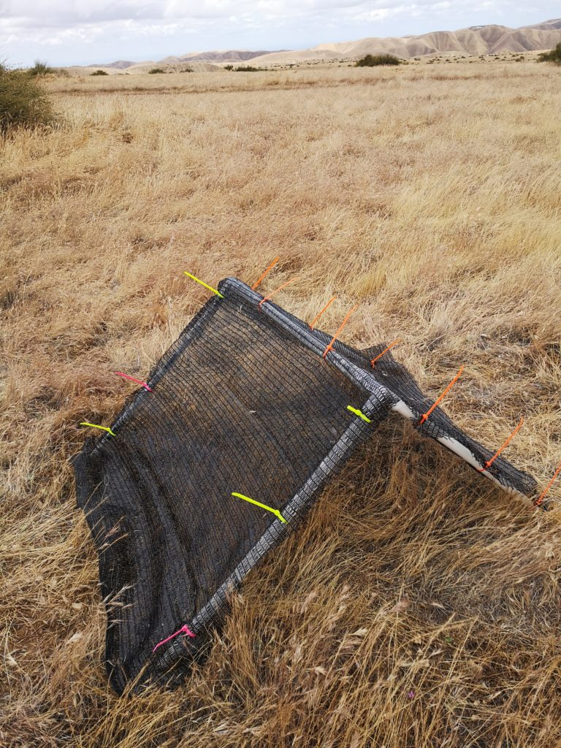

**Figure 2. Heat Map visualizing temperature (°F) during the study period at the different microsites. Darker red colours corresponds to cooler temperature whilst bright yellow colours correspond to warmer temperatures. heat map is pretty but I find it hard to tell differences between microsites.. maybe facet into microsites? or try a different way to arrange**

**improve y-axis labels**

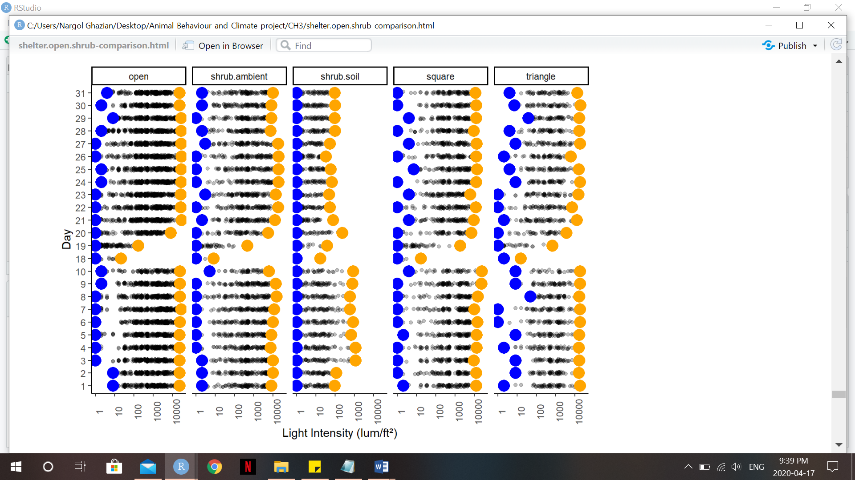**Figure 3. Scatter plot of light intensity (lum/ft2) over the duration of the study period at each microsite. Yellow dots represent maximum intensity, while blue dots represent minimum intensity experienced during each day.**

**same here - I cannot tell the difference between stuff at all - maybe ask Mario and Malory too but really hard for me to see differences. not bad tho!! can you change colors too? max - red, min - blue? do same for temp plots**

**these points show each day - what did daily boxplots look like? too hard to tell apart?**

**Table 1. Generalized Linear Model (GLM) for predicting temperature. 95% Confidence Intervals are provided along with the p-value for each microsite. Significant p-values (p<0.05) are bolded.**

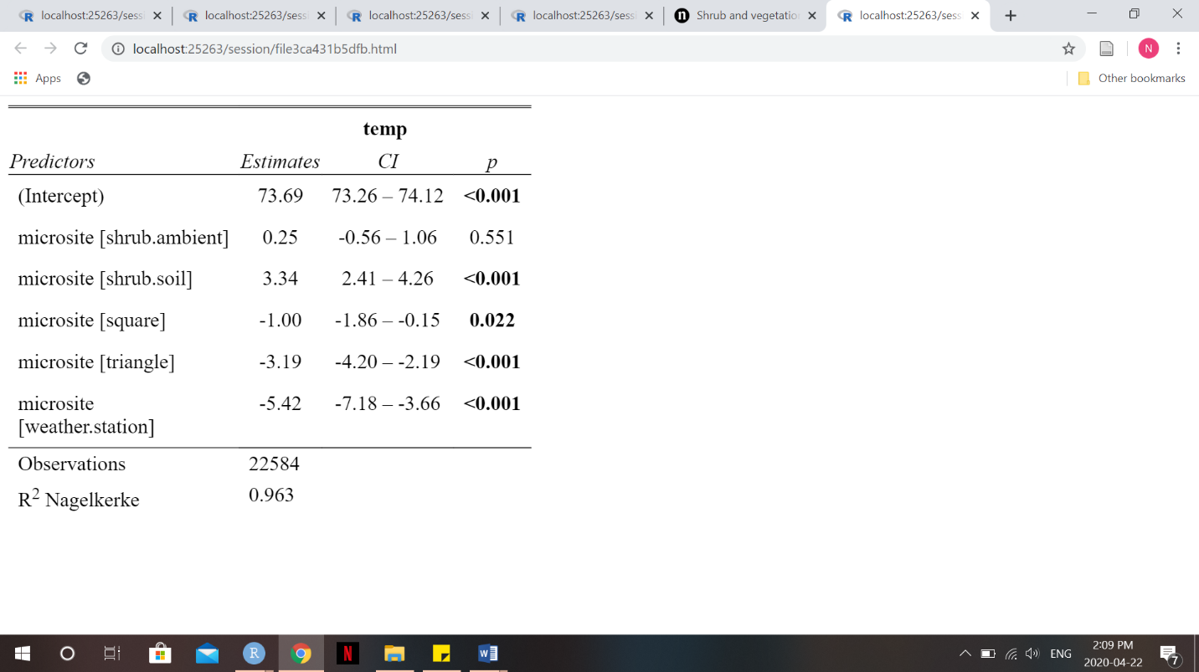

**Table 2. Estimated Marginalized Mean (EMM) and standard error (SE) are given for each microsite based on temperature GLM. Confidence Interval used is 95%.**

|  |  |  |  |  |
| --- | --- | --- | --- | --- |
| ***Microsite*** | ***emmean*** | ***SE*** | ***Asymp.LCL*** | ***Asymp.UCL*** |
| open | 73.7 | 0.219 | 73.3 | 74.1 |
| shrub.ambient | 73.9 | 0.351 | 73.2 | 74.6 |
| shrub.soil | 77.0 | 0.417 | 76.2 | 77.8 |
| square | 72.7 | 0.378 | 71.9 | 73.4 |
| triangle | 70.5 | 0.463 | 69.6 | 71.4 |
| weather.station | 68.3 | 0.872 | 66.6 | 70.0 |
| ***Microsite Pr(>Chisq)= 0.0001*** | | | | |

**Table 3. Pairwise analysis of microsites based on temperature GLM. Standard error and p-values are given. Significant p-values are bolded.**

|  |  |  |  |  |
| --- | --- | --- | --- | --- |
| ***Contrast*** | ***estimate*** | ***SE*** | ***z.ratio*** | ***p-Value*** |
| open-shrub.ambient | -0.247 | 0.414 | -0.597 | 0.9913 |
| open-shrub.soil | -3.337 | 0.471 | -7.077 | **0.0001** |
| open-square | 1.005 | 0.437 | 2.298 | 0.1947 |
| open-triangle | 3.195 | 0.512 | 6.238 | **0.0001** |
| open-weather.station | 5.42 | 0.899 | 6.029 | **0.0001** |
| shrub.ambient-shrub.soil | -3.09 | 0.545 | -5.665 | **0.0001** |
| shrub.ambient-square | 1.252 | 0.516 | 2.426 | 0.1473 |
| shrub.ambient-triangle | 3.442 | 0.581 | 5.952 | **0.0001** |
| shrub.ambient-weather.station | 5.667 | 0.94 | 6.030 | **0.0001** |
| shrub.soil-square | 4.342 | 0.563 | 7.708 | **0.0001** |
| shrub.soil-triangle | 6.532 | 0.623 | 10.480 | **0.0001** |
| shrub.soil-weather.station | 8.757 | 0.967 | 9.059 | **0.0001** |
| square-triangle | 2.19 | 0.598 | 3.664 | **0.0034** |
| square-weather.station | 4.415 | 0.95 | 4.646 | **0.0001** |
| triangle-weather.station | 2.225 | 0.987 | 2.254 | 0.2131 |

**Table 4. Generalized Linear Model (GLM) for predicting light intensity. 95% Confidence Intervals are provided along with the p-value for each microsite. Significant p-values (p<0.05) are bolded.**

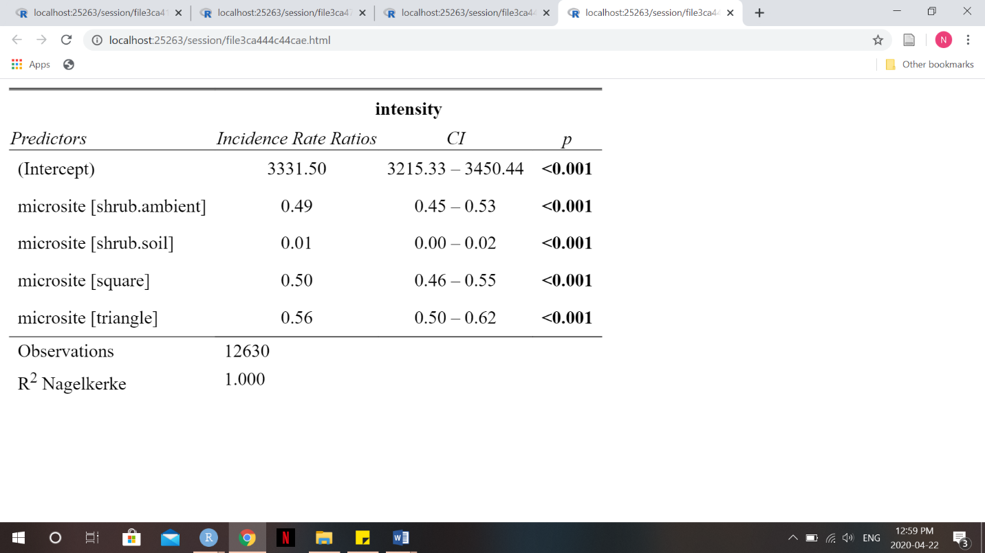

**Table 5. Estimated Marginalized Mean (EMM) and standard error (SE) are given for each microsite based on light intensity GLM. Results are given on the log scale and Confidence Interval used is 95%.**

|  |  |  |  |  |
| --- | --- | --- | --- | --- |
| ***Microsite*** | ***emmean*** | ***SE*** | ***Asymp.LCL*** | ***Asymp.UCL*** |
| open | 8.111 | 0.018 | 8.076 | 8.146 |
| shrub.ambient | 7.395 | 0.04146 | 7.314 | 7.476 |
| shrub.soil | 3.522 | 0.4142 | 2.711 | 4.334 |
| square | 7.424 | 0.04371 | 7.338 | 7.51 |
| triangle | 7.529 | 0.05124 | 7.429 | 7.63 |
| ***Microsite Pr(>Chisq)= 0.0001*** | | | | |

**Table 6. Pairwise analysis of microsites based on light intensity GLM. Standard error and p-values are given. Significant p-values are bolded and confidence level used is 95%. Results are given on the log scale.**

|  |  |  |  |  |
| --- | --- | --- | --- | --- |
| ***Contrast*** | ***estimate*** | ***SE*** | ***z.ratio*** | ***p-Value*** |
| open-shrub.ambient | 0.7161 | 0.0452 | 15.842 | **0.0001** |
| open-shrub.soil | 0.5889 | 0.4146 | 11.068 | **0.0001** |
| open-square | 0.6873 | 0.0473 | 14.539 | **0.0001** |
| open-triangle | 0.5821 | 0.0543 | 10.718 | **0.0001** |
| shrub.ambient-shrub.soil | 3.8728 | 0.4163 | 9.304 | **0.0001** |
| shrub.ambient-square | -0.0287 | 0.0602 | -0.477 | 0.9895 |
| shrub.ambient-triangle | -0.134 | 0.0659 | -2.032 | 0.2505 |
| shrub.soil-square | -0.9015 | 0.4165 | -9.367 | **0.0001** |
| shrub.soil-triangle | -4.0068 | 0.4174 | -9.600 | **0.0001** |
| square-triangle | -0.1052 | 0.0674 | -1.562 | 0.5218 |

**Supplementary Appendix**

**A. A list of PVC pieces used for shelter skeleton construction is provided alongside the quantity needed to build one of each shelter-type.**

|  |  |  |
| --- | --- | --- |
| ***Piece*** | ***Quantity for Triangular Shelter*** | ***Quantity for Rectangular Shelter*** |
| 61 cm (½ inch diameter) pipe | 4 | 4 |
| 61 cm (¾ inch diameter) pipe | NA | 2 |
| 75 ¾ cm pipe | 1 | NA |
| ½ inch to ¾ inch adapter | 2 | NA |
| ½ inch to ¾ inch 2-way 90º elbow | NA | 4 |
| ½ inch 3-way 90º elbow | 2 | NA |

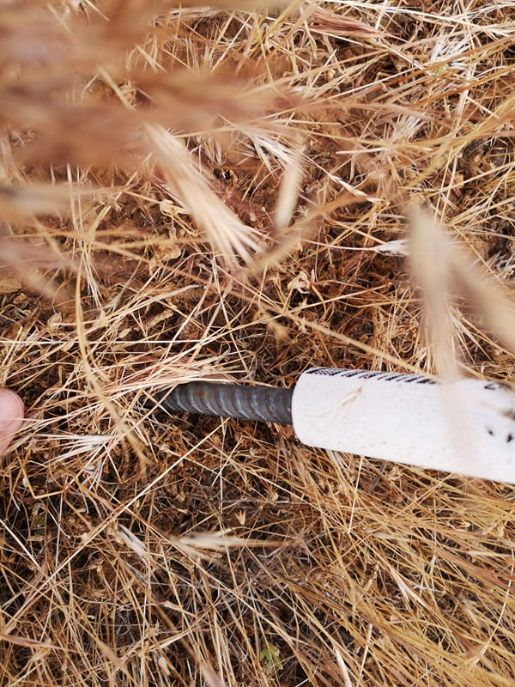

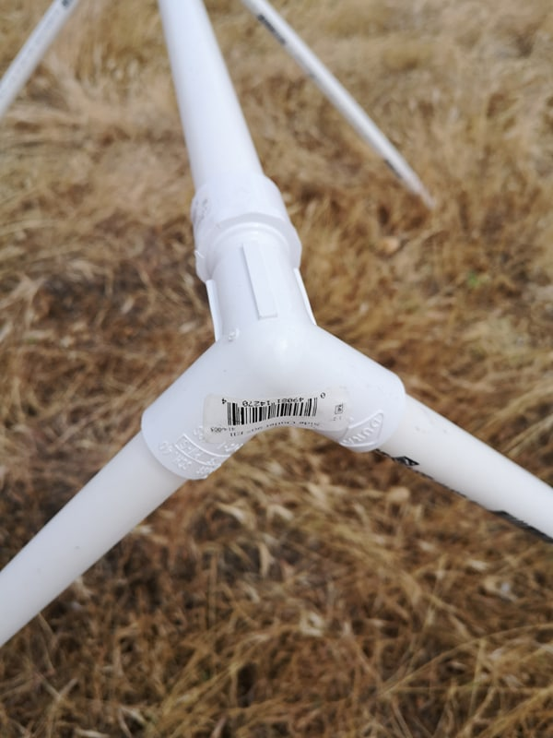

**B. Left- General PVC triangular structure and joint. Right-Metal stake and with PVC pipe slid on.**

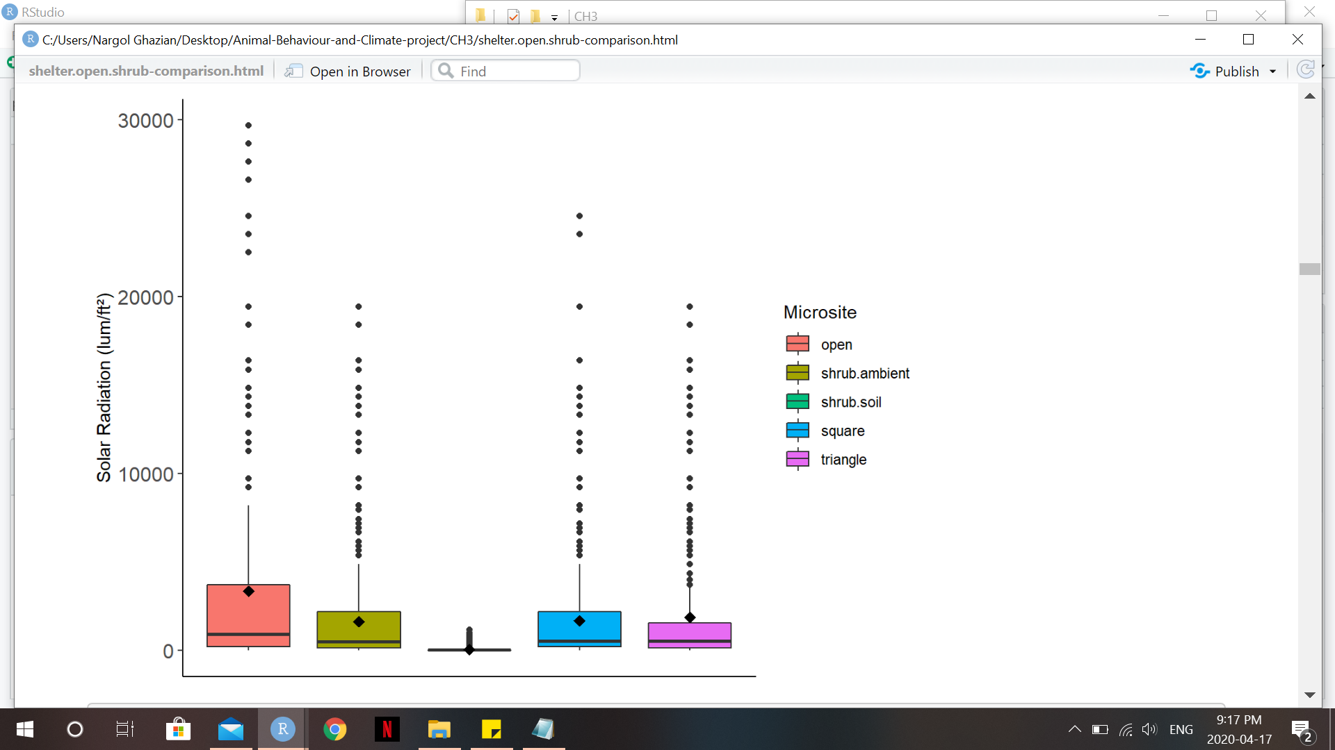**C. Box plot showing temperature (°F) at each microsite. Solid middle lines shows the median of the data, whilst whiskers show 1.5 standard deviation. Solid dots are outliers >1.5 interquartile range (IQR). Diamonds dots represent the mean.**

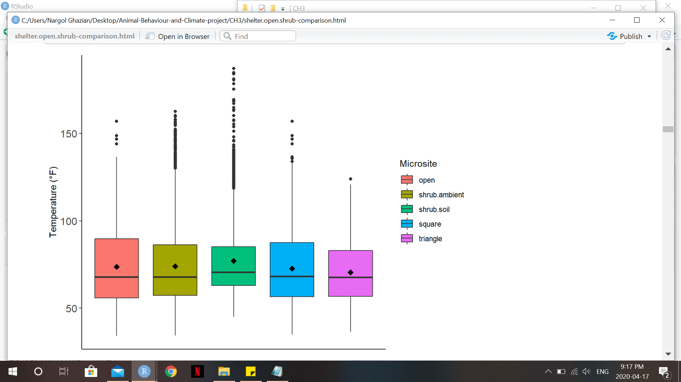

**D. Box plot showing light intensity (lum/ft2) at each microsite. Solid middle lines shows the median of the data, whilst whiskers show 1.5 standard deviation. Solid dots are outliers >1.5 interquartile range (IQR). Diamonds dots represent the mean.**

**E. Pairwise contrast of temperature at different microsites by cover type. Results are given at 95% CI. Significant p-values are bolded.**

|  |  |  |  |  |  |
| --- | --- | --- | --- | --- | --- |
| ***Cover Type*** | ***Contrast*** | ***estimate*** | ***SE*** | ***z.ratio*** | ***p-Value*** |
| 0 | Open-triangle | -26.593 | 21.532 | -1.235 | 0.4324 |
| 15 | Square-triangle | 1.031 | 1.126 | 0.916 | 0.6301 |
| 50 | Square-triangle | 0.584 | 1.123 | 0.52 | 0.8616 |
| 90 | Square-triangle | 3.527 | 3.527 | 3.853 | **0.0003** |
| ***Microsite Pr (>Chisq)= 0.0001***  ***Cover Pr (>Chisq)=0.0001*** | | | | | |

**F. Pairwise contrast of light intensity at different microsites by cover type. Results are given at 95% CI on the log scale. Significant p-values are bolded.**

|  |  |  |  |  |  |
| --- | --- | --- | --- | --- | --- |
| ***Cover Type*** | ***Contrast*** | ***estimate*** | ***SE*** | ***z.ratio*** | ***p-Value*** |
| 0 | Open-triangle | -0.267 | 1.293 | -0.207 | 0.9767 |
| 15 | Square-triangle | -0.893 | 0.102 | -8.746 | **0.0001** |
| 50 | Square-triangle | 0.477 | 0.195 | 2.454 | **0.0376** |
| 90 | Square-triangle | 0.619 | 0.129 | 4.779 | **0.0001** |
| ***Microsite Pr (>Chisq)= 0.0001***  ***Cover Pr (>Chisq)=0.0001*** | | | | | |

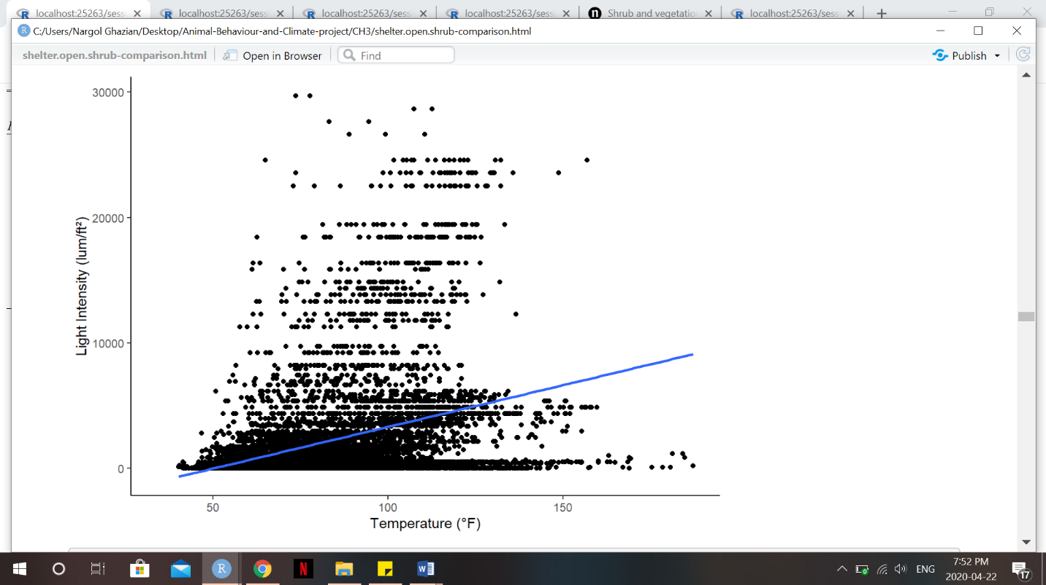

**G. Scatterplot showing the relationship between light intensity (lum/ft2) and temperature (°F). Blue line represents smooth conditional mean (Kendall’s tau=0.281, p=0.0001).**

**H. Location (latitude and longitude coordinates) of each shelter-open microsite is given, alongside its shape and cover type.**

|  |  |  |  |  |
| --- | --- | --- | --- | --- |
| ***Shelter ID*** | ***Latitude*** | ***Longitude*** | ***Shape (Triangle/Square)*** | ***Cover type*** |
| *1* | 36.69363 | -120.79318 | T | 15% |
| *2* | 36.69364 | -120.79331 | S | 15% |
| *3* | 36.69355 | -120.79315 | S | 90% |
| *4* | 36.69349 | -120.79320 | T | 90% |
| *5* | 36.69349 | -120.79311 | T | 50% |
| *6* | 36.39342 | -120.79311 | S | 50% |
| *7* | 36.69394 | -120.79300 | S | 15% |
| *8* | 36.69397 | -120.79292 | T | 15% |
| *9* | 36.69401 | -120.79282 | S | 90% |
| *10* | 36.694 | -120.79295 | T | 90% |
| *11* | 36.69405 | -120.79305 | S | 50% |
| *12* | 36.69408 | -120.79301 | T | 50% |

**I. Location (latitude and longitude coordinates) of shrub microsites.**

|  |  |  |
| --- | --- | --- |
| ***Shrub ID*** | ***Latitude*** | ***Longitude*** |
| 1 | 36.69532 | -120.797 |
| 2 | 36.69592 | -120.797 |
| 3 | 36.69533 | -120.794 |
| 4 | 36.69598 | -120.797 |
| 5 | 36.69591 | -120.797 |
| 6 | 36.69605 | -120.797 |
| 7 | 36.69595 | -120.798 |

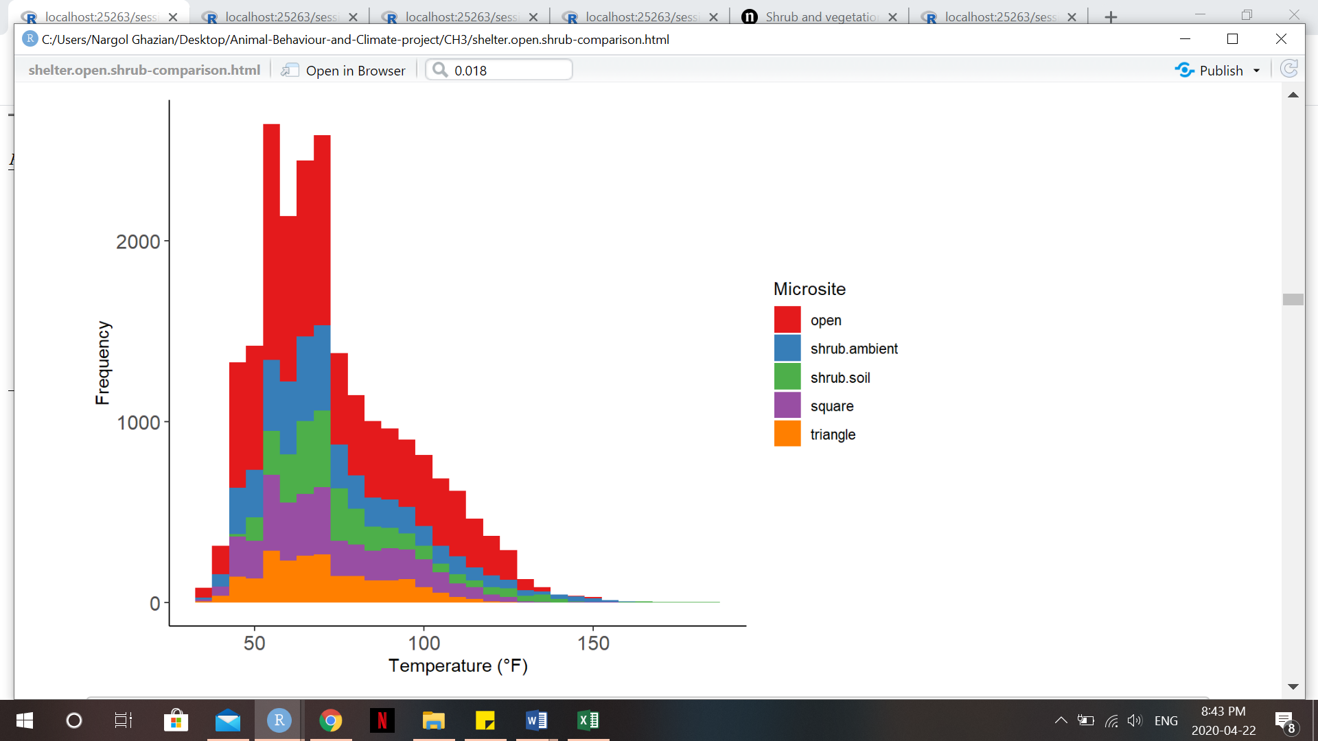

**J. Frequency histogram of temperatures (°F) recorded at each microsite. Higher temperatures were recorded at a greater frequency in the open.**